1679 words – Cover.doc
With TWO photos:
Cover.jpg: Queensway Carleton Hospital community donning their “QCH Strong” toques. (L-R) Darien Backstrom, QCH Screener, Nicholas Lomonossoff, Volunteer, Dr. Andrew Falconer, President & CEO, Judy Gula, Special Care Nursery RN, Jaason Geerts (CCHL), Taryn Neil, Pharmacy Technician. Photo courtesy of Kelly Spence.
Imagining health leadership after the pandemic
By Jaason Geerts
We’re at mile marker 35 (of 26.2) in the marathon of COVID-19 response and the finish line continues to find furtive ways of eluding us. Those racing on fumes are nervous that if the sixty seconds of Kipling’s “unforgiving minute” extend much longer, the physical and the mental toll of this distance run will become dire.
As the timelines for international herd immunity lengthen and experts warn of the endemic potential of COVID-19, it seems unlikely that we’ll see a quick and definite end to this crisis in the conceivable future.
And yet, imagining a post-pandemic world (the Resolution Stage) can perhaps provide the focus and motivation that is desperately needed during this phase. After all we have been through together; having exposed the deplorable gaps in the system, its failures and the losses - along with having realized the very best of humanity - our collective resilience and resolve, our collaborative successes, our breakthrough innovations, our unwavering partnerships - it is hard to imagine a scenario without an unrepenting global expectation that things must be better - that we must apply lessons learned and make sure that things are better – as we move forward.
“Better” means improved global health and healthcare, as well as unequivocal advancements in the parallel priorities of Long-Term Care (LTC), equity, diversity, and inclusion (EDI), and climate change. The more vivid the picture we have of the landscape and life in the Resolution Stage, the more efficacious that picture can be as a North Star to guide our current work, even without an official End of the Pandemic Day!
At all costs, we must avoid drifting into the Waiting it Out (until it’s over) syndrome and limiting our weary sights on the immediate priorities, at the expense of a future-looking strategic mindset. As the gradual progression toward crisis resolution rumbles on, central to health leadership in 2021 is maintaining organizational stamina, capacity, and confidence that, as trying as it is, envisioning and co-creating the path to Resolution will make things markedly better for staff, patients, families, and communities.

Imagining the future of health leadership
To prepare this article, we contacted nearly 100 CEO’s and senior leaders of Canadian hospitals, provincial and regional health authorities, and national health organizations, asking them the following questions: 1) What imperatives or priorities will be most important for leaders after the pandemic? 2) What leadership capabilities will be most important to enable leaders to implement those imperatives priorities/address those priorities? 3) Any further insights into effective leadership after the pandemic? These questions form the structure of what follows.
Leadership priorities after the pandemic
Celebrating people. The Queensway Carleton Hospital’s “QCH strong” t-shirts and toques (see photo) attest to the fundamental importance of acknowledging the remarkable contributions and dedication of staff at all levels, since they are bricoleurs entrusted with advancing the path toward resolution.
Recovery for people. This includes providing psychologically and culturally safe environments, compassion, care, and support for the mental, physical, spiritual, and emotional wellbeing of staff. Particular concern should be extended to those who have undergone chronic stress and traumatic experiences. Health human resources (HR) is a related urgent priority in terms of retention and recruitment, since vacancies are high and many are leaving healthcare, while the demand for staff is soaring (Cameron Love, CEO, The Ottawa Hospital (TOH)). Leaders need support too, given the weight of the burden they have borne throughout the pandemic (Karen Biggs, CEO of Menno Place). No progress can be made in collapse.
Recovery of care. The operational task of tackling the backlog of paused services, screening, diagnostics, and care, as well as other unintended harm caused by the pandemic, needs to be orchestrated within the limits of available beds, resources, staffing, and financial constraints. Though wrought with harrowing tradeoffs at times, this is an opportunity to reconsider how to most effectively and efficiently move forward.
Actioning and resourcing lessons learned. Synthesizing the lessons learned at the individual, team, organizational, and system levels, as well as actioning and resourcing them, provides the foundation for system transformation and for future pandemic preparedness (Alain Doucet, CEO, Canadian College of Health Leaders (CCHL)). This includes discussing how to sustain improvements and create pathways for higher quality and innovation in non-crisis environments (Brenda Lammi, Vice President, CCHL).
Clarifying the heart of the matter. Shifting sights to the future begins with collectively re-examining the “reason to be” and quintessential relevance of the organization (Suzanne McGurn, CEO of Canadian Agency for Drugs and Technologies in Health (CADTH)), along with “the highest value of our work,” while ruthlessly clarifying what is non-essential (Frank Vassallo, CEO of Kemptville District Hospital). Next is revisiting strategic priorities to ensure that they reflect the renewed focus (Jo-Ann Marr, CHE, CEO of Markham Stouffville Hospital).
Addressing gaps and inequities in the system and enhancing integrated care. This begins with isolating the root causes of cracks in the system, identifying priority populations and opportunities for greater access and EDI, and implementing sustainable reforms (Dr. Tim Rutledge, CEO, Unity Health Toronto). A system-wide perspective is needed to critically examine how to best integrate care among hospitals, Primary Care, Home Care, LTC, Community Care, etc. and to decrease reliance on hospitals significantly. This requires advocating for changes in legislation and policy (Caroline Lidstone-Jones, CHE, CEO of the Indigenous Primary Health Care Council (IMPACC)) and a commitment of bona fide leadership and political will to see this through, not one-off initiatives (Dr. Andy Smith, CEO of Sunnybrook Health Sciences Centre).
Optimizing work and care. It is important to discuss how teams, organizations, and systems can optimize work and care delivery models, including by upskilling staff and maintaining key strategic and operational partnerships (Hélène Sabourin, co-chair of Organizations for Health Action (HEAL) and CEO of the Canadian Association of Occupational Therapists (CAOT)). The organizational carbon footprint should also be considered.
In addition to providing focus and direction, these processes can be precursors to another key priority, which is to “revitalize, reenergize, and inspire leadership” across the system (Marianne Walker, CHE, CEO of Guelph General Hospital). Similarly, Julia Hanigsberg, CEO of Holland Bloorview Kids Rehabilitation Hospital, suggests that the pivotal question is, “What will remind people why they love working in healthcare and help to re-find that joy in work?”
Three questions for reflection are: 1) What immediate priorities and tasks are most essential, given the heart of the matter for the organization? 2) What in the immediate priorities and tasks should not be? 3) What approaches to the most essential immediate priorities and tasks could lead us to a better, more equitable future?

Key capabilities
To address these priorities successfully, thirty-one different capabilities were proposed, which are represented in the word cloud below. The most common (in larger font) were resilience, transparent communication, empathy, and build relationships.
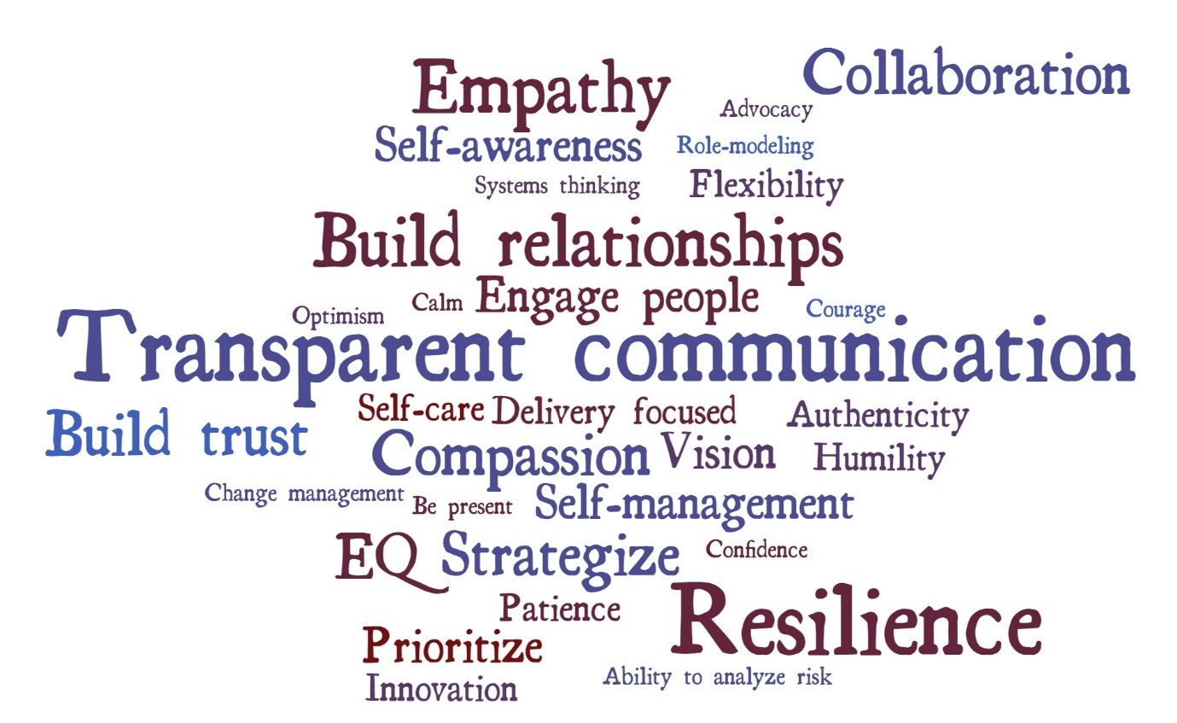
Leadership in the Resolution Stage will require the tenacity to get the hard stuff done, including making bold and, at times, unpopular decisions (Dr. Andy Smith). Uniting many of these key capabilities, Col. Scott Malcolm, MD (Deputy Surgeon General, Canadian Armed Forces), suggests that essential to effective communication is understanding one’s people so that one can create the narratives that are most likely to resonate with each of them.
Keys to success
Four overarching themes emerged as keys to success in the responses to the final question of our study.
- Restoration will be needed: people are exhausted and many have struggled more so than we might realize (Dr. Verna Yiu, CEO, Alberta Health Services). We must moderate expectations and strike a balance between system priorities and staff health, wellness, and capacity (Patrick Gaskin, CHE, CEO, Cambridge Memorial Hospital; Ray Racette, CHE, CEO, Lake of the Woods District Hospital). One CEO concluded, “We have to look after each other.” including leader self-care, and reclaim a healthier work/life balance than many have been sustaining for over a year.
- This is the time to bring desperately needed transformational changes to our healthcare systems. If this pandemic isn’t enough to ignite a passionate commitment to fundamental improvements, it is hard to imagine what would. One CEO summarized the imperative: “we absolutely cannot go back.”
- There are calls for a major shift away from silos within organizations and from treating health care organizations as independent providers toward a community-based approach across the spectrum of care involving complementary services, including health promotion and prevention. This must include Long-Term Care, EDI, and climate change as cardinal components of the healthcare system, all of which have been largely treated as externalities until now. It is essential that governments and organizational boards appreciate the importance of this approach.
- Identifying proven and emerging leaders, particularly those with high Emotional Intelligence, and providing them with further opportunities and training to continue to succeed is key (Sandy Jensen, CEO, Tillsonburg District Memorial Hospital). This involves developing leadership in equity populations and ensuring that they have the tools and resources they need (Caroline Lidstone-Jones).

To conclude, Dr. Jackie Schleifer Taylor, interim President and CEO of London Health Sciences Centre (LHSC), explains, “You might not know when [the marathon] ends and you may not be familiar with the path, but the leader’s job is to ensure that you know that the path is going to be wonderful at the end and that we will come out richer in our understanding of how our health systems have to change for the better.”
If we hold a vivid picture of Resolution in our collective imagination, we may just find the invigoration and fuel that is most likely to sustain us through the remaining miles of this unforgiving distance run and to make the awaiting landscape and life more richly ours… for us all.
** This article is the second in a series on health leadership during the pandemic and is informed by more than a year of international research projects by the Canadian College of Health Leaders (CCHL), funded in part by Healthcare Excellence Canada (HEC)).

Jaason Geerts, PhD is the Director of Research and Leadership Development at the Canadian College of Health Leaders.
